|  |
| --- |
| alwazz designs 2014 |
| Assignment-2nd |
| **Wheel of Luck** |
| Version # AL-1.0#1.5  All work Copyright © 2014  By ALWAZZ DESIGNS.  All rights reserved. |
| **[PAVITTAR SINGH]** |
|  |



|  |
| --- |
| OCT 25th 2014 |

**Version History**

This Slot machine has been designed with the version #AL-1.0

*VERSION #al-1.0* - October 12, 2014

* **Feature:** The Wheel of luck is available.

*VERSION #al-1.1* - October 13, 2014

* **Feature:** New look of spin buttons, reset button and power button.
* **Feature:** Interface changed with new look.
* **Feature:** Improved behavior for result sheet.
* **Bug fixes:** Assorted styling fixes.

*VERSION #al-1.2* – October 15, 2014

* **Bug fixes:** Over 200 bug fixes for beta 3.

*VERSION #al-1-3* – October 18, 2014

* **Feature:** setup the new company logo.
* **Bug fixes:** Position error fixed.

*VERSION #al-1.4* – october 20, 2014

* **Feature:** New picture for interface has been applied.

*VERSION #Al-1.5* - OCTOBER 25, 2014

* **Feature:** New Buttons.

The week of luck has been design to spend some time to have some fun. This game has very good feature to check how many do you have lucky stars. This game is good app to spend some time for have fun.

1. **Game Overview**

*(This game design to have some fun and see about is that in real world luck works or not. This game has option to spend money for bet and after User can see did he win the jackpot or not. This slot machine has good option to spend and earn some money in real world. If user’s luck is sharp than user can win jackpot.)*

1. **Game Play Mechanics**

*(In this application there are no any limitation to choose your bet amount. User have full freedom to put the bet amount in input and once user put the bet amount into the input box than User need to spin the button for check the luck. After a spin User can see the result in the sidebar into the result sheet. There are a display box which has been design to show the appropriate message to the user about wining and loss status. This message box has been create to check the message as well to see the winning amount about the prize. If any case by luck user win the jackpot than the user will get the display message about jackpot in same message box.)*

1. **Browsers**

*(This slot machine has special URL to control it and it has top central position in any of web browsers)*

1. **Controls**

*(In this machine there are just 3 keys thought that we can easily control this machine.*

* 1. *Spin button: spin button has vital role for this machine and through this button we can spin the reel for see the result. After result user have the again option to spin it for check the luck.*
  2. *Reset the button: If any case user want to quit the turns and new user want to use this machine than the reset button has vital role to reset all the controls and get ready to machine for next user. With the use of the machine you can see the controls in default positions.*
  3. *Power Button: If no body want to use this machine than the power button has good role to quit the machine from browser. The button used for save energy and Quit the browser for the appropriate use of browser and the machine.*
  4. *Input box: This input box has the main role in the machine because through this input box user has option to put the desired amount for bet. There are no any limitation to enter the desired bet amount but it should be less than player money because machine can just spin the bet from provided money.)*

1. **Saving and Loading**

*(There are no any option to save the game because there are no make sense we need to save the bet record. This is the gambling and this machine never save any spin record. The machine has just one result box to display the result of spins and it can show how many time user spin and how many time it win and loss. It’s work before reset the machine.*

*)*

1. **Interface Sketch**

*(This inter face designed same as Slot Machine looks like. So going to put a screen shot of interface.)*

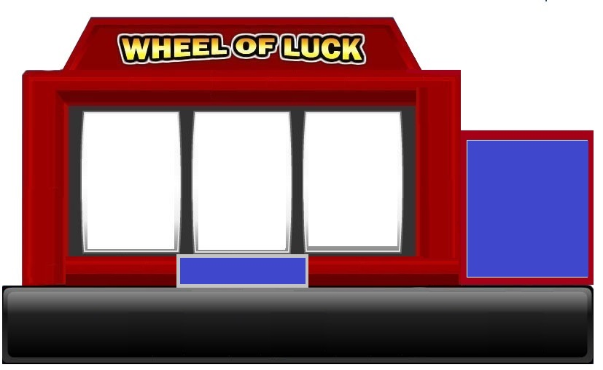

1. **Menu and Screen Descriptions**

*(There are some additional screen shot which can show the working machine.)*

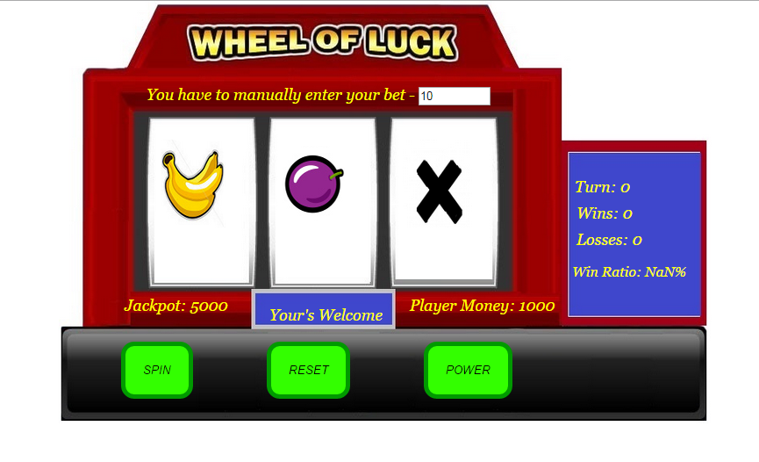

**Screen shot of spin**